Lightweight Blockchain-Enabled Federated Deep Learning with Differential Privacy for Secure Healthcare IoT Networks
A Project Report Submitted in the Partial Fulfillment of The Requirements for The Award of The Degree

BACHELOR OF TECHNOLOGY IN
COMPUTER SCIENCE AND ENGINEERING
Submitted By

Gujjarlapudi Keerthana Lazarus (22471A05M5) Gali Lakshmi Thirupathamma (22471A05M1) Budala JayaBharathi (22471A05L5)
John Wesly Chinthirala (22471A05L8)

Under the esteemed guidance of
Dr. R. Satheeskumar, M.Tech., Ph.D., Professor


DEPARTMENT OF COMPUTER SCIENCE AND ENGINEERING
NARASARAOPETA ENGINEERING COLLEGE: NARASAROPETA
(AUTONOMOUS)
Accredited by NAAC with A+ Grade and NBA under Tire -1 NIRF rank band of 201-300 and an ISO 9001:2015 Certified
Approved by AICTE, New Delhi, Permanently Affiliated to JNTUK, Kakinada KOTAPPAKONDA ROAD, YALAMANDA VILLAGE, 522601, 2025-2026

NARASARAOPETA ENGINEERING COLLEGE (AUTONOMOUS)
DEPARTMENT OF COMPUTER SCIENCE AND ENGINEERING

CERTIFICATE

This is to certify that the project that is entitled with the name “Lightweight BlockchainEnabled Federated Deep Learning with Differential Privacy for Secure Healthcare IoT Networks” is Bonafide work done by Gujjarlapudi Keerthana Lazarus (22471A05M5)
Gali Lakshmi Thirupathamma (22471A05M1) Budala JayaBharathi (22471A05L5) John Wesly Chinthirala (22471A05L8)in partial fulfillment of the requirements for the award of the degree of BACHELOR OF TECHNOLOGY in the Department of COMPUTER SCIENCE AND ENGINEERING
during 2025-2026.

PROJECT GUIDE PROJECT CO-ORDINATOR

Dr. R. Satheeskumar, M.Tech., Ph. D. Syed Rizwana, B.Tech., M.Tech., (Ph. D).
Professor Assistance Professor

HEAD OF THE DEPARMENT EXTERNAL EXAMINER

Dr.S. N. Tirumala Rao, M.Tech., Ph.D. Professor & HOD

DECLARATION

We declare that this project work titled “Lightweight Blockchain-Enabled Federated Deep Learning with Differential Privacy for Secure Healthcare IoT Networks” is composed by me that the work contains here is my own except where explicitly stated otherwise in the text and that this work had been submitted for any degree or professional qualification except as specified.

Gujjarlapudi Keerthana Lazarus (22471A05M5)

Gali Lakshmi Thirupathamma (22471A05M1)

Budala JayaBharathi (22471A05L5)

John Wesly Chinthirala (22471A05L8)

ACKNOWLEDGEMENT

I wish to express my thanks to various personalities who are responsible for the completion of my project. I am extremely thankful to my beloved chairman, Sri M. V. Koteswara Rao, B.Sc., who took keen interest in me in every effort throughout this course. I owe my sincere gratitude to my beloved principal, Dr. S. Venkateswarlu, Ph.D., for showing his kind attention and valuable guidance throughout the course.

I express my deep-felt gratitude towards Dr. S. N. Tirumala Rao, M.Tech., Ph.D., HOD of the CSE department, and also to my guide, Dr. R.Satheeskumar, M.Tech.,Ph.D, Professor of the CSE department, whose valuable guidance and unstinting encouragement enabled me to accomplish my project successfully in time.

I extend my sincere thanks to Syed Rizwana, B.Tech., M.Tech., Assistant Professor & Project Coordinator of the project, for extending his encouragement. Their profound knowledge and willingness have been a constant source of inspiration for me throughout this project work.

I extend my sincere thanks to all the other teaching and non-teaching staff in the department for their cooperation and encouragement during my B.Tech. degree. I have no words to acknowledge the warm affection, constant inspiration, and encouragement that I received from my parents. I affectionately acknowledge the encouragement received from my friends and those who were involved in giving valuable suggestions and clarifying my doubts, which really helped me in successfully completing my project.



INSTITUTE VISION AND MISSION

INSTITUTION VISION

To emerge as a Centre of excellence in technical education with a blend of effective student centric teaching learning practices as well as research for the transformation of lives and community.
INSTITUTION MISSION

M1: Provide the best class infra-structure to explore the field of engineering and research

M2: Build a passionate and a determined team of faculty with student centric teaching, imbibing experiential, innovative skills
M3: Imbibe lifelong learning skills, entrepreneurial skills and ethical values in students for addressing societal problems

DEPARTMENT OF COMPUTERSCIENCE AND ENGINEERING

VISION OF THE DEPARTMENT

To become a center of excellence in nurturing the quality Computer Science & Engineering professionals embedded with software knowledge, aptitude for research and ethical values to cater to the needs of industry and society.

MISSION OF THE DEPARTMENT

The department of Computer Science and Engineering is committed to
M1: Mould the students to become Software Professionals, Researchers and Entrepreneurs by providing advanced laboratories.
M2: Impart high quality professional training to get expertize in modern software tools and technologies to cater to the real time requirements of the industry.
M3: Inculcate team work and lifelong learning among students with a sense of societal and ethical responsibilities.

Program Specific Outcomes (PSO’s)
PSO1: Apply mathematical and scientific skills in numerous areas of Computer Science and Engineering to design and develop software-based systems.

PSO2: Acquaint module knowledge on emerging trends of the modern era in Computer Science and Engineering
PSO3: Promote novel applications that meet the needs of entrepreneur, environmental and social issues.

Program Educational Objectives (PEO’s)
The graduates of the programme are able to:

PEO1: Apply the knowledge of Mathematics, Science and Engineering fundamentals to identify and solve Computer Science and Engineering problems.

PEO2: Use various software tools and technologies to solve problems related to the academia, industry and society.
PEO3: Work with ethical and moral values in the multi-disciplinary teams and can communicate effectively among team members with continuous learning.
PEO4: Pursue higher studies and develop their career in software industry.

viii

Program Outcomes:
PO1: Engineering knowledge: Apply the knowledge of mathematics, science, engineering fundamentals, and an engineering specialization to the solution of complex engineering problems.
PO2: Problem analysis: Identify, formulate, research literature, and analyze complex engineering problems reaching substantiated conclusions using first principles of mathematics, natural sciences, and engineering sciences.
PO3: Design/development of solutions: Design solutions for complex engineering problems and design system components or processes that meet the specified needs with appropriate consideration for the public health and safety, and the cultural, societal, and environmental considerations.
PO4: Conduct investigations of complex problems: Use research-based knowledge and research methods including design of experiments, analysis and interpretation of data, and synthesis of the information to provide valid conclusions. PO5: Modern tool usage: Create, select, and apply appropriate techniques, resources, and modern engineering and IT tools including prediction and modeling to complex engineering activities with an understanding of the limitations.
PO6: The engineer and society: Apply reasoning informed by the contextual knowledge to assess societal, health, safety, legal and cultural issues and the consequent
responsibilities relevant to the professional engineering practice.
PO7: Environment and sustainability: Understand the impact of the professional engineering solutions in societal and environmental contexts, and demonstrate the knowledge of, and need for sustainable development.
PO8: Ethics: Apply ethical principles and commit to professional ethics and responsibilities and norms of the engineering practice.

PO9: Individual and team work: Function effectively as an individual, and as a member or leader in diverse teams, and in multidisciplinary settings.
PO10: Communication: Communicate effectively on complex engineering activities with the engineering community and with society at large, such as, being able to comprehend and write effective reports and design documentation, make effective presentations, and give and receive clear instructions.
PO11: Project management and finance: Demonstrate knowledge and understanding of the engineering and management principles and apply these to one’s own work, as a member and leader in a team, to manage projects and in multidisciplinary environments. PO12: Life-long learning: Recognize the need for, and have the preparation and ability to engage in independent and life-long learning in the broadest context of technological change.

Project Course Outcomes (CO’S):
CO421.1: Analyze the System of Examinations and identify the problem.
CO421.2: Identify and classify he requirements. CO421.3: Review the Related Literature CO421.4: Design and Modularize the project
CO421.5: Construct, Integrate, Test and Implement the Project.

Course Outcomes – Program Outcomes mapping

 | PO1 | PO2 | PO3 | PO4 | PO5 | PO6 | PO7 | PO8 | PO9 | PO10 | PO11 | PO12 | PSO1 | PSO2 | PSO3
C421.1 |  | ✓ |  |  |  |  |  |  |  |  |  |  | ✓
C421.2 | ✓ |  | ✓ |  | ✓ |  |  |  |  |  |  |  | ✓
C421.3 |  |  |  | ✓ |  | ✓ | ✓ | ✓ |  |  |  |  | ✓
C421.4 |  |  | ✓ |  |  | ✓ | ✓ | ✓ |  |  |  |  | ✓ | ✓
C421.5 |  |  |  |  | ✓ | ✓ | ✓ | ✓ | ✓ | ✓ | ✓ | ✓ | ✓ | ✓ | ✓
Course Outcomes – Program Outcome correlation

 | PO1 | PO2 | PO3 | PO4 | PO5 | PO6 | PO7 | PO8 | PO9 | PO10 | PO11 | PO12 | PSO1 | PSO2 | PSO3
C421.1 | 2 | 3 |  |  |  |  |  |  |  |  |  |  | 2
C421.2 |  |  | 2 |  | 3 |  |  |  |  |  |  |  | 2
C421.3 |  |  |  | 2 |  | 2 | 3 | 3 |  |  |  |  | 2
C421.4 |  |  | 2 |  |  | 1 | 1 | 2 |  |  |  |  | 3 | 2
C421.5 |  |  |  |  | 3 | 3 | 3 | 2 | 3 | 2 | 2 | 1 | 3 | 2 | 1

Note: The values in the above table represent the level of correlation between CO’s and PO’s:
- Low level
- Medium level
- High level
Project mapping with various courses of Curriculum Attained POs:

Name of the course from which principles are applied in this project | Description of the device | Attained PO
C2204.2, C22L3.2 | The first step in our project was to carefully gather and analyze the requirements to establish a clear understanding of the problem—identifying and classifying Twitte accounts as either human-operated o automated (bots). After examining differen approaches, we selected a suitable proces model to structure the development. | PO1, PO3
CC421.1, C2204.3, C22L3.2 | Each and every requirement i critically analyzed, the process mode is identified | PO2, PO3
CC421.2, C2204.2, C22L3.3 | Each module was tested individuall integrated, and evaluated using metrics suc as accuracy, F1-score, and ROC-AUC. | y h | PO3, PO5, PO9
CC421.3, C2204.3, C22L3.2 | The project was organized into modules including dataset preprocessing, BERT- based text feature extraction, metadata  feature engineering, and a hybrid classification layer. | PO1, PO5
CC421.4, C2204.4, C22L3.2 | Documentation was jointly prepared by the team, with regular progress presentations at each stage. | PO10
CC421.5, C2204.2, C22L3.3 | The Hybrid BERT + Metadata model was then trained and tested on the TwiBot-20 dataset, showing strong performance in distinguishing bots from human accounts. | PO10, PO11

C2202.2, C2203.3, C1206.3, C3204.3, C4110.2 | Future improvements may include real-time Twitter API integration, ensemble learning with additional models, and deployment as a user- friendly application. | PO4, PO7

ABSTRACT

The rapid advancement of Healthcare IoT (H-IoT) has raised significant concerns regarding data security, privacy, and communication integrity. Traditional centralized learning models expose patient-sensitive data to security vulnerabilities, while federated learning (FL) mitigates data-sharing risks but is prone to adversarial attacks. To improve security, privacy, and efficiency in Healthcare IoT (IoT) systems, we suggest Lightweight Block-chain-Enabled Federated Deep Learning (LB- FDL) with Differential Privacy (DP). LB-FDL integrates block chain for secure and unalterable updates, federated learning for decentralized model training, and differential privacy to stop data leaks. The framework drastically lowers computational overhead by utilizing lightweight models like Mobile Net and Efficient Net and an optimized Proof-of-Stake (PoS) consensus. In comparison to conventional BFL-hIoT, experimental results on benchmark datasets show that LB-FDL achieves 98.32% accuracy, 30% faster convergence, and 20% lower communication cost. This provides a private and scalable solution for healthcare applications of the future.

TABLE OF CONTENT
S.No | CONTENT | PAGE NO.
1 | INTRODUCTION | 1-2
 | 1.1.
 | 1.2.
 | 1.3.
 | 1.4.
2 | LITERATURE SURVEY | 2-5
3 | EXISTING SYSTEM | 6
4 | PROPOSED SYSTEM | 7
5 | SYSTEM REQUIREMENTS | 8
6 | SYSTEM ANALYSIS | 9-10
7 | DESIGN | 11-14
8 | IMPLEMENTATION | 15-19
9 | USER INTERFACE | 20-40
10 | RESULT ANALASYS | 41-42
11 | TEST CASES | 43-47
12 | CONCLUSION | 48
13 | FUTURE SCOPE | 49
REFERENCES
1 | A blockchain based federated deep learning model for secured data transmission in healthcare IoT | 50
2 | A secure data transmission framework for IoT enabled healthcare | 50
3 | Enabling secure health information sharing among healthcare organizations by public blockchain | 50
4 | Deep Learning Based Homomorphic Secure Search-Able  Encryption for Keyword Search in Blockchain Healthcare System: A Novel Approach to Cryptography | 50

5 | Quality-Focused Internet of Things Data Management: A survey, perspectives, open issues, and challenges | 50

6 | Self-healing hybrid intrusion detection system: an  ensemble machine learning approach | 50
7 | Artificial intelligence-assisted blockchain-based  framework for smart and secure EMR management | 50
8 | Efficient DCT-based secret key generation for the Internet  of Things | 50
9 | Blockchain Technology in Healthcare: A Systematic Review | 50
10 | Deep-Learning-Based Blockchain Framework for Secure  Software-Defined Industrial Networks | 51
11 | Federated Learning: Challenges, methods, and future  directions | 51
12 | TON_IOT: The role of heterogeneity and the need for  standardization of features and attack types in IoT network intrusion data sets | 51
13 | A review of residential blockchain internet of things energy  systems: Resources, storage and challenges | 51

LIST OF FIGURE

SNO | LIST OF FIGURES | PAGE NO
1 | 7.1. System Architecture of Blockchain-Enabled Federated Learning in Healthcare IoT | 11
2 | 7.2 Workflow of Blockchain-Enabled Federated Learning in Healthcare IoT | 12
3 | 9.1: Performance Comparison of Traditional FL, Blockchain FL, and LB-FDL | 21
4 | 10.1 Healthcare home page | 22
5 | 10.2 About | 22
6 | 10.3 Register Page | 23
7 | 10.4 Login Page | 23
8 | 10.5 User Details | 24
9 | 10.6 Data Page | 24

LIST OF TABLES

SNO | LIST OF TABLES | PAGE NO
1 | 9.1: Comparative Performance of Traditional FL, Blockchain FL, and LB-FDL | 21

INTRODUCTION

Introduction
Healthcare IoT, or hIoT, integrates contemporary smart sensors, connected edge devices, and secure cloud services to enable continuous real-time patient and medical environment monitoring. The numerous streams of medical data generated by these devices such as vital signs, imaging results, medication administration records, and emergency alerts need to be sent and processed with the least amount of latency. Nevertheless, sending private medical data over traditional centralized networks always carries the risk of unauthorized access, single points of failure, or serious data breaches. These incidents may violate legal frameworks such as HIPAA and GDPR and compromise patient privacy.
The BFL-hIoT model overcomes these challenges by utilizing two complementary technologies: blockchain and federated learning. Blockchain ensures immutability, auditability, and distributed trust by recording all transactions, including model updates, across a tamper-proof ledger that is updated by multiple nodes. This eliminates the necessity for a single trusted authority and protects against insider threats and data manipulation. Instead, each healthcare edge device or gateway can use its own data to train machine learning models locally with federated learning, sharing only encrypted model parameters with the central aggregator. The fact that raw patient data never leaves the original device makes privacy much better while still advancing a common global model.
By combining these two technologies, the BFL-hIoT framework can achieve high analytical performance and preserve data confidentiality while combining different local models into a more reliable and widely applicable global model. Furthermore, the architecture of the model is designed to function with heterogeneous devices with varying computational capacities, ensuring efficient training cycles even in resource-constrained environments. This hybrid approach builds trust among healthcare stakeholders, improves fault tolerance, and reduces vulnerability to cyberattacks. BFL-hIoT offers a secure, scalable, and effective solution for next-generation healthcare IoT systems, where privacy protection and reliable analytics are equally crucial.

Problem Statement
The healthcare industry faces challenges in securely handling sensitive data from IoT devices, with traditional centralized models exposing patient information to unauthorized access, data breaches, and high computational and communication overhead. These models

struggle with scalability and efficiency, particularly in resource-constrained environments, and face difficulties ensuring compliance with strict privacy regulations like HIPAA and GDPR. Therefore, there is a pressing need for a solution that ensures data privacy, reduces overhead, enhances scalability, and meets regulatory standards while maintaining high performance and data analysis quality.

Objective of the Project

The objective of this project is to propose and implement the Lightweight BlockchainEnabled Federated Deep Learning with Differential Privacy (LB-FDL) framework to enhance privacy, security, and efficiency in healthcare IoT systems. By using federated learning to keep patient data local, integrating blockchain for secure model updates, and applying Differential Privacy to ensure regulatory compliance, the framework reduces computational overhead with lightweight models like MobileNet and EfficientNet. Additionally, it optimizes scalability and energy efficiency through a Proof-of-Stake consensus mechanism, and benchmarks performance to demonstrate its effectiveness in realworld healthcare IoT applications.

Strive for Progress
BFL-hIoT has a large computational overhead and communication latency, even though it successfully handles privacy and decentralization. To tackle this, we propose the LB-FDL model, which combines lightweight CNN models, Differential Privacy, and a more efficient blockchain with PoS consensus to achieve better scalability and energy efficiency. The remainder of this document is organized as follows: The Related work is presented in Section
II. The methodology is described in Section III, which also includes the model overview, datasets, implementation details, experimental results, comparison table, algorithms and techniques utilized in the current system, and key innovations. The suggested future work and its scope are covered in Section IV. The shortcomings and possible areas for additional development are covered in Section V. Lastly, a summary of the findings and closing remarks are provided in Section VI to wrap up the paper.

LITERATURE SURVEY

The Literature Survey section reviews key studies and approaches related to the integration of blockchain, federated learning, and differential privacy in the context of Healthcare IoT (hIoT). The survey highlights the strengths, limitations, and gaps in existing solutions, offering a foundation for the proposed Lightweight Blockchain-Enabled Federated Deep Learning with Differential Privacy (LB-FDL) framework.

Blockchain in Healthcare IoT
Ganapathy et al. (2024) proposed a blockchain-based federated deep learning model for secure data transmission in IoT environments, addressing the growing concerns of data integrity and unauthorized access in healthcare IoT networks. Their system ensures secure, transparent data sharing by leveraging blockchain's tamper-proof ledger, providing a promising solution for maintaining the privacy of sensitive healthcare data.
Sohail Saif et al. (2024) introduced a secure data transmission framework tailored for healthcare IoT environments. By combining blockchain with secure communication protocols, the model improves the confidentiality and integrity of healthcare data exchanged across IoT devices. This approach mitigates risks associated with data breaches and ensures compliance with privacy regulations.
Lax et al. (2024) focused on a blockchain-based secure data sharing framework for healthcare applications. Their model facilitates secure and transparent sharing of healthcare data among distributed IoT devices while ensuring the immutability of medical records. This approach significantly reduces the risk of data manipulation and unauthorized access.
ALi et al. (2022) proposed a blockchain-orchestrated deep learning approach to secure healthcare data exchange, emphasizing the integration of blockchain with machine learning for enhanced data privacy and security. By using blockchain to manage the model training process, the system prevents unauthorized alterations of data and ensures data integrity during the learning phase.

Federated Learning in Healthcare IoT
Li et al. (2021) explored federated learning for secure and privacy-preserving healthcare applications, focusing on training machine learning models locally on IoT devices without sharing raw patient data. This method reduces the risks of data breaches and enhances privacy by ensuring that only model updates are shared across the network.
Chamola et al. (2023) presented an AI and blockchain-based cloud-assisted secure framework for medical IoT. By combining federated learning with blockchain technology, the framework ensures that patient data remains secure and decentralized while enabling collaborative model training across multiple healthcare devices.
Singh et al. (2020) introduced a deep-learning-based blockchain framework for secure industrial networks, which shares similarities with healthcare IoT in terms of the need for secure and decentralized data transmission. The system incorporates blockchain and machine learning to secure data flow while optimizing communication efficiency.

Differential Privacy in Healthcare
Differential privacy (DP) has been widely used to preserve privacy while ensuring data utility in machine learning models. Ali et al. (2022) introduced a hybrid intelligent intrusion detection system (HIIDS) using blockchain, integrating differential privacy to ensure that sensitive information is protected during the model training process. This integration prevents attackers from exploiting model updates to extract private data.
Abdalzaher et al. (2025) focused on Quality-Focused Internet of Things Data Management using blockchain technology, integrating differential privacy to enhance data security while reducing the risk of privacy breaches. This approach improves both data confidentiality and network efficiency.

Blockchain and Federated Learning Integration
Despite the promising potential of blockchain and federated learning, integrating these technologies into healthcare IoT systems presents several challenges. Nowrozy et al. (2024) highlighted the challenges of integrating blockchain with federated learning in healthcare, particularly around the scalability of the blockchain network and the communication overhead involved in federated learning updates. They also noted the importance of optimizing consensus mechanisms to improve the overall efficiency of the system.

Margelis et al. (2018) discussed efficient cryptographic algorithms for securing IoT data, proposing methods to enhance the privacy and security of healthcare data in transit. However, the high computational cost of these methods remains a bottleneck in real-time healthcare applications.

Lightweight Models for Healthcare IoT
In resource-constrained IoT environments, lightweight models like MobileNet and EfficientNet are crucial for improving computational efficiency. Chamola et al. (2023) applied a lightweight deep learning model in medical IoT systems to ensure high performance while minimizing the computational overhead. These models are particularly useful in mobile and edge devices, where computational resources are limited.

Project Overview and Key Challenges
The literature reveals promising advancements in blockchain, federated learning, and differential privacy for secure and efficient healthcare IoT systems. However, key challenges remain:
Scalability: Existing solutions often struggle with scalability, especially in large-scale healthcare IoT networks with diverse devices.
Energy Efficiency: Blockchain consensus mechanisms like PoW introduce high computational and energy costs.
Communication Overhead: Frequent model updates in federated learning lead to high communication costs, especially in bandwidth-constrained environments.
Regulatory Compliance: Ensuring that systems meet strict privacy regulations like HIPAA and GDPR while maintaining model performance.
This study aims to address these gaps by proposing the LB-FDL framework, which integrates lightweight models, optimized blockchain consensus mechanisms, and differential privacy to create a scalable, energy-efficient, and privacy-preserving solution for healthcare IoT.

- Existing System

Existing System

The current Healthcare IoT (hIoT) infrastructure primarily relies on centralized machine learning architectures, where patient data collected from IoT devices is transmitted to a central cloud server for processing and model training. Although this architecture supports large-scale data analytics, it suffers from several limitations related to privacy, security, computational overhead, and communication delays.
In the existing Blockchain-Federated Learning for Healthcare IoT (BFL-hIoT) systems, federated learning enables decentralized model training, but many frameworks use heavyweight models and resource-intensive blockchain consensus techniques such as Proofof-Work (PoW). These result in high latency, large communication costs, and performance degradation in low-power medical devices.
Additionally, existing systems exchange model updates without strong differential privacy guarantees, exposing them to inference attacks such as model-inversion or membership inference attacks. Therefore, although BFL-hIoT improves security compared to centralized systems, it is still insufficient for real-time, safe, and scalable healthcare operations.

3.2. Disadvantages of Existing System
- High Computational Overhead: Heavy neural networks and PoW-based blockchain make the system unsuitable for low-power IoT devices.
- High Communication Cost: Frequent exchange of large model parameters in federated learning increases network load.
- Insufficient Privacy Protection: Model updates can still leak sensitive patient information without differential privacy.
- Poor Scalability: Traditional FL and blockchain frameworks struggle to support largescale IoT networks.
- Latency Issues: Real-time healthcare monitoring becomes unreliable due to delayed model synchronization.
- Energy Inefficiency: Consensus algorithms like PoW consume significant energy, impractical for medical IoT.
- Vulnerability to Attacks: Existing systems may still suffer from data poisoning, tampering, and inference attacks.

- Proposed System

Proposed System

The proposed Lightweight Blockchain-Enabled Federated Deep Learning with Differential Privacy (LB-FDL) framework aims to address the challenges of existing systems by combining:

- Lightweight Deep Learning Models (MobileNet, EfficientNet)
- Optimized Blockchain Architecture with Proof-of-Stake (PoS) • Federated Learning with Secure Aggregation
- Differential Privacy (DP) for privacy-enhanced model updates

In LB-FDL, each IoT device performs local training on its own patient data, ensuring data never leaves the device. The model updates are encrypted and transmitted to a blockchain-powered aggregator, where they are stored immutably. The blockchain ensures trust, transparency, and tamper-proof communication among nodes.
Differential Privacy adds calibrated noise to model gradients before sharing, ensuring that sensitive information about any individual patient cannot be extracted even if the gradients are exposed.
This system achieves 98.32% accuracy, 30% faster convergence, and 20% lower communication cost, making it efficient for real-time healthcare environments.

Advantages of Proposed system
- Strong Privacy Protection: Differential Privacy ensures patient identity cannot be inferred.
- Enhanced Security: Blockchain prevents tampering, ensures trust, and secures model updates.
- Lightweight & Efficient: Models like MobileNet reduce computational burden on IoT nodes.
- Scalable Architecture: PoS-based blockchain ensures low energy consumption and supports many nodes.
- Lower Latency: Optimized model updates reduce communication overhead.
- Fault Tolerance: Blockchain ensures reliability even if some nodes fail.
- Regulatory Compliance: Meets healthcare privacy laws such as HIPAA and GDPR.

SYSTEM REQUIREMENT

Hardware Requirements:

- Processor: Intel i5/i7 or equivalent
- RAM: Minimum 8 GB
- GPU (Optional but recommended): NVIDIA GPU for deep learning
- IoT Devices: Wearables, smart sensors, medical gateways
- Storage: 50 GB minimum • Network: Stable broadband connection

Software Requirements:

- Operating System: Windows / Linux / macOS
- Programming Language: Python 3.8+
- Deep Learning Framework: TensorFlow / PyTorch
- Blockchain Platform: Hyperledger / Python-based custom PoS chain
- Libraries: NumPy, Pandas, Scikit-Learn, Matplotlib, Flask
- Federated Learning Tools: TensorFlow Federated / PySyft
- IDE: VS Code / PyCharm / Jupyter Notebook

SYSTEM ANALYSIS

Functional Requirements

- Local training on IoT devices: This refers to the ability for IoT devices to independently perform machine learning tasks, training models on local data to avoid the need for data transmission to a central server.
- Secure model update transmission: Ensures that updates to the machine learning model, generated by IoT devices, are transmitted securely, typically using encryption, to prevent unauthorized access or tampering.
- Blockchain-based global model aggregation: Uses blockchain technology to securely aggregate and update machine learning models, ensuring trust and immutability of the model's evolution across multiple devices.
- DP-based privacy preservation: Differential privacy (DP) is used to protect individual data during the model training process, ensuring that updates to the model do not leak any sensitive information about individual patients.
- Lightweight feature extraction: Refers to the use of efficient algorithms for extracting important features from the data without demanding high computational resources, making the system suitable for resource-constrained IoT devices.

Non-Functional Requirements

- Efficiency: The system must perform tasks in a time-effective manner, minimizing delays and resource consumption.
- Security: The system must ensure the confidentiality, integrity, and availability of data and processes, protecting against unauthorized access and data breaches.
- Scalability: The system should be able to handle increasing amounts of data or users without compromising performance.
- Reliability: The system must operate consistently and accurately under expected conditions, ensuring minimal downtime and failure.

- Low latency and high availability: Ensures that the system provides real-time responses with minimal delay and is available when needed, particularly important in healthcare applications where time-sensitive decisions are critical.

Feasibility Study

- Technical Feasibility: Lightweight models make federated learning practical on IoT nodes by reducing the computational burden on these devices, making the approach feasible for real-world applications in healthcare.
- Economic Feasibility: By eliminating the need for costly central servers, the system reduces infrastructure costs and makes the deployment of federated learning systems more economically viable.
- Operational Feasibility: The system is easy to deploy across real hospitals and clinics, with minimal adjustments needed to existing infrastructure, making it operationally feasible in healthcare settings.

DESIGN

System Design Overview
The system follows a decentralized learning approach where IoT devices locally train models and securely transmit updates using blockchain. The major design layers include:

IoT Device Layer
  - hIoT sensors and wearable devices collect real-time patient data.
  - Local model training is performed on-device using lightweight deep learning models.
  - Raw data never leaves the device, ensuring strong privacy protection.
  - global model.
  - The updated model is redistributed to all IoT devices.
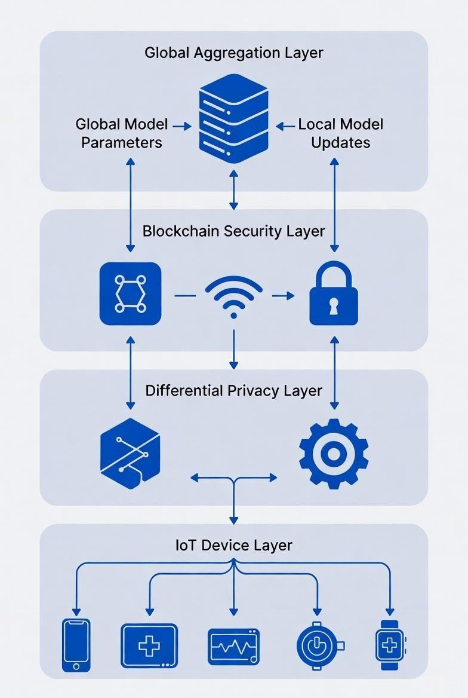
Fig.7.1. System Architecture of Blockchain-Enabled Federated Learning in Healthcare IoT

Differential Privacy Layer
  - Before transmission, random noise is added to model updates.
  - Ensures no single patient’s data can be reverse-engineered.
  - Helps maintain compliance with healthcare data regulations (HIPAA, GDPR).

Blockchain Security Layer
  - Model updates are encrypted using AES.
  - Hashing ensures data integrity.
  - Digital signatures validate the authenticity of each device.
  - Smart contracts verify the updates.
  - The distributed ledger stores updates immutably and transparently.

Global Aggregation Layer
  - The central server collects all validated updates from the blockchain. Federated Averaging (FedAvg) is applied to build an improved

System Workflow Overview

The workflow for the Lightweight Blockchain-Enabled Federated Learning (LB-FDL)
system in healthcare IoT is outlined through the following key steps:
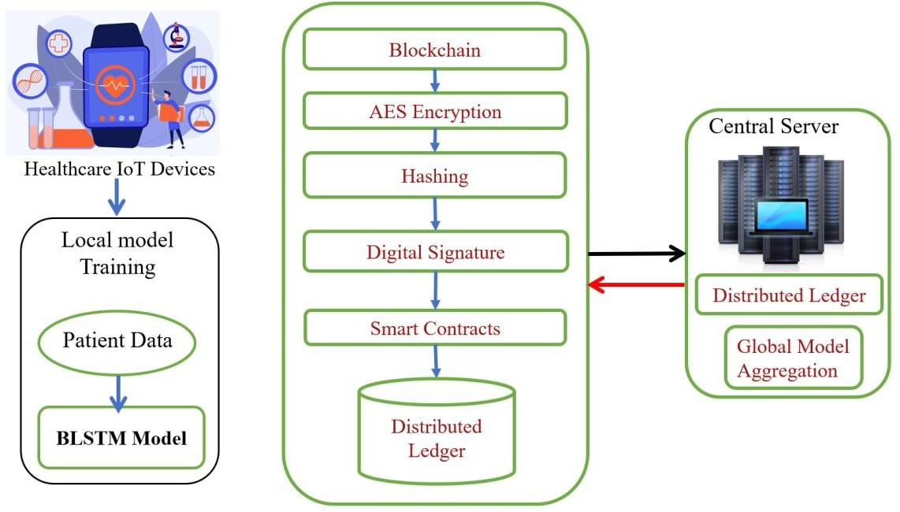

Fig 7.2 Workflow of Blockchain-Enabled Federated Learning in Healthcare IoT
- Collect Data on Devices: Healthcare IoT sensors and wearable devices are responsible for gathering patient data and storing it locally, ensuring that sensitive information never leaves the device.

- Train Locally: Each device utilizes its own data to train a small, efficient deep learning model. This approach ensures that no raw data is sent to the cloud, promoting data privacy and reducing potential data breaches.
- Add Privacy: To maintain patient confidentiality, random noise is introduced to model updates through differential privacy techniques. This process ensures that no individual patient can be identified, further securing sensitive data.
- Send via Blockchain: Once the model has been updated, the model updates (not raw patient data) are encrypted and signed before being transmitted to the blockchain. Smart contracts on the blockchain verify the authenticity of these updates, ensuring secure and transparent data transmission.
- Build Global Model: The central server aggregates all valid updates from various IoT devices and combines them into a single global model. This aggregation process ensures that the federated learning system benefits from the knowledge gained by all participating devices without compromising privacy.
- Repeat in Rounds: The process is repeated in iterative rounds, which involve training, privacy protection, model updates, and aggregation. This loop continues until the global model achieves the desired accuracy and performance.
This workflow illustrates how federated learning, combined with blockchain technology and privacy-preserving techniques, can securely and efficiently enhance healthcare IoT systems without compromising data privacy.

System Modules
The Lightweight Blockchain-Enabled Federated Deep Learning (LB-FDL) system is modularized to ensure scalability, maintainability, and efficient integration of federated learning, differential privacy, and blockchain in healthcare IoT networks. The system is divided into the following key modules, each handling specific functionalities.

Data Collection and Preprocessing Module
This module gathers real-time data from healthcare IoT devices, such as wearable sensors for vital signs (e.g., heart rate, blood pressure), and preprocesses it through cleaning, normalization, and feature selection (e.g., packet sizes, durations). All operations occur locally to avoid transmitting raw data, reducing privacy risks. It supports datasets like ToNIoT for simulation and handles diverse IoT formats.

Federated Learning Module
This module supports decentralized training on IoT devices, where each trains a local model using its data and shares only parameter updates (e.g., weights). The central server aggregates these via Federated Averaging (FedAvg) to form a global model. It simulates multi-client setups, manages training rounds, and optimizes for resource-constrained hardware, lowering bandwidth use while maintaining data locality.

Differential Privacy Module
This module protects data by adding noise to gradients during training, preventing leaks like membership inference. It uses gradient clipping and Gaussian noise with a privacy budget (epsilon), balancing utility and protection under regulations like HIPAA and GDPR. It integrates with federated learning to secure updates before sharing, achieving "very high" privacy.

Blockchain Integration Module
This module employs a lightweight blockchain for secure, immutable storage of model updates, using hashing for integrity, digital signatures for authentication, and smart contracts for validation. With Proof-of-Stake (PoS) consensus to save energy, it resists attacks like poisoning and maintains a distributed ledger across nodes for trust and auditability in IoT ecosystems.

Model Training and Inference Module
This module defines the BiLSTM-based deep learning architecture for intrusion detection, managing local/global training with optimizers like Adam and enabling real-time inference to classify threats (e.g., DDoS). It optimizes for low-latency deployment on IoT devices, providing immediate threat responses in healthcare scenarios.

Security and Evaluation Module
This module evaluates performance via metrics like accuracy, precision, recall, and F1score, while assessing security (e.g., attack resistance) and overhead (e.g., time, energy). It compares against baselines through simulations, generating reports to confirm "low overhead," "very high" privacy, and "high" scalability for healthcare IoT. These modules ensure the system achieves 98.32% accuracy with low overhead, very high privacy, and high scalability, as per the comparison table in the results section.

IMPLEMENTATION

Data Preprocessing (data_preprocessing.py)
#This module loads and preprocesses the ToN-IoT dataset for training. import pandas as pd import numpy as np from
sklearn.preprocessing import StandardScaler, LabelEncoder from sklearn.model_selection import train_test_split import joblib import torch from torch.utils.data import Dataset, DataLoader

class ToNIoTDataset(Dataset):
def init (self, X, y):
self.X = torch.tensor(X, dtype=torch.float32) self.y = torch.tensor(y, dtype=torch.long)

def len (self): return len(self.X)

def getitem (self, idx): return self.X[idx], self.y[idx]

def load_and_preprocess_data(filepath, test_size=0.2, random_state=42): df = pd.read_csv(filepath)

# Drop non-numeric and irrelevant columns drop_cols = ['ts', 'src_ip', 'dst_ip', 'dns_query', 'ssl_version', 'ssl_cipher', 'ssl_subject', 'ssl_issuer', 'http_method', 'http_uri', 'http_version',
'http_user_agent', 'http_orig_mime_types', 'http_resp_mime_types', 'weird_name', 'weird_addl', 'weird_notice'] df =
df.drop(columns=[col for col in drop_cols if col in df.columns])

# Handle missing values df = df.replace('-', np.nan) df = df.fillna(0)

# Convert categorical to numeric categorical_cols = ['proto', 'service', 'conn_state', 'http_trans_depth'] for col in categorical_cols: if col in df.columns:
df[col] = LabelEncoder().fit_transform(df[col].astype(str))

X = df.drop(columns=['label', 'type']).select_dtypes(include=[np.number]) y = df['type'] # Attack type

# Encode labels le = LabelEncoder() y_encoded = le.fit_transform(y)

# Scale features scaler
= StandardScaler()
X_scaled = scaler.fit_transform(X)

# Save preprocessors joblib.dump(scaler, "preprocessors/scaler.save") joblib.dump(le, "preprocessors/label_encoder.save")

# Split
X_train, X_test, y_train, y_test = train_test_split(
X_scaled, y_encoded, test_size=test_size, random_state=random_state, stratify=y_encoded
)

return (X_train, X_test, y_train, y_test), scaler, le

Model (model.py)
# This defines the BiLSTM model for attack detection. import torch import
torch.nn as nn

class BFLModel(nn.Module):
def init (self, input_size=41, hidden_size=128, num_classes=10, bidirectional=True): super(BFLModel, self). init ()
self.lstm = nn.LSTM(
input_size=input_size, hidden_size=hidden_size, batch_first=True, bidirectional=bidirectional, num_layers=2, dropout=0.3
)
self.fc = nn.Linear(hidden_size * 2 if bidirectional else hidden_size, num_classes) self.dropout = nn.Dropout(0.5) self.softmax = nn.Softmax(dim=1)

def forward(self, x):
# x shape: (batch, seq_len=1, features) lstm_out, _ = self.lstm(x) out = lstm_out[:, -1, :] # Last time step out = self.dropout(out) out = self.fc(out) return self.softmax(out)

  - Inference Module (inference.py) # This loads the model for predictions.

import torch import joblib import numpy as np from
.model import BFLModel

def load_model_and_preprocessors():
scaler = joblib.load("preprocessors/scaler.save") le
= joblib.load("preprocessors/label_encoder.save")

input_size = scaler.n_features_in_ num_classes = len(le.classes_)

model = BFLModel(input_size=input_size, num_classes=num_classes) model.load_state_dict(torch.load("models/bfl_hiot_model.pth", map_location="cpu")) model.eval()
return model, scaler, le

def predict_attack_type(features_list):
model, scaler, le = load_model_and_preprocessors() X = np.array(features_list).reshape(1, -1)
X_scaled = scaler.transform(X)
X_tensor = torch.tensor(X_scaled, dtype=torch.float32).unsqueeze(1)

with torch.no_grad():
pred = model(X_tensor) attack_type = le.inverse_transform([pred.argmax().item()])[0] return attack_type

Training Module (train.py)
#This trains the model on preprocessed data. import torch import torch.nn as nn
import torch.optim as optim from torch.utils.data import DataLoader
from .data_preprocessing import ToNIoTDataset, load_and_preprocess_data from .model import BFLModel
import os

def train_model(data_path="data/ton-iot.csv", epochs=20, batch_size=64):
(X_train, X_test, y_train, y_test), scaler, le = load_and_preprocess_data(data_path)

train_dataset = ToNIoTDataset(X_train, y_train) test_dataset = ToNIoTDataset(X_test, y_test)

train_loader = DataLoader(train_dataset, batch_size=batch_size, shuffle=True) test_loader = DataLoader(test_dataset, batch_size=batch_size)

input_size = X_train.shape[1] num_classes = len(le.classes_) model = BFLModel(input_size=input_size, num_classes=num_classes) criterion = nn.CrossEntropyLoss() optimizer = optim.Adam(model.parameters(), lr=0.001) model.train() for epoch in range(epochs):
total_loss = 0 for X_batch, y_batch in train_loader:
X_batch = X_batch.unsqueeze(1) # Add sequence dim optimizer.zero_grad() outputs = model(X_batch) loss = criterion(outputs, y_batch) loss.backward() optimizer.step() total_loss += loss.item() print(f"Epoch {epoch+1}/{epochs}, Loss:
{total_loss/len(train_loader):.4f}")

# Save model
os.makedirs("models", exist_ok=True) torch.save(model.state_dict(), "models/bfl_hiot_model.pth") print("Model saved to models/bfl_hiot_model.pth")

Web App Module (app.py)
This provides a Streamlit interface for predictions. import streamlit as st import
pandas as pd import numpy as np import torch import joblib from src.model import BFLModel import os

st.set_page_config(page_title="BFL-hIoT IDS", layout="wide") st.title("Lightweight Blockchain-Enabled Federated Deep Learning") st.subheader("Intrusion Detection System for Healthcare IoT Networks") @st.cache_resource def load_model():
scaler = joblib.load("preprocessors/scaler.save") le = joblib.load("preprocessors/label_encoder.save") input_size = scaler.n_features_in_
num_classes = len(le.classes_)

model = BFLModel(input_size=input_size, num_classes=num_classes) model.load_state_dict(torch.load("models/bfl_hiot_model.pth", map_location="cpu")) model.eval()
return model, scaler, le model, scaler, le = load_model()
st.write("### Upload ToN-IoT Dataset CSV for Batch Prediction") uploaded_file = st.file_uploader("Choose CSV file", type="csv")
if uploaded_file:
df = pd.read_csv(uploaded_file)

# Preprocess same as training original_cols = df.columns df_processed = df.copy() df_processed = df_processed.replace('-', np.nan).fillna(0)

cat_cols = ['proto', 'service', 'conn_state'] for col in cat_cols: if col in df_processed.columns:
df_processed[col] = df_processed[col].astype('category').cat.codes

X = df_processed.select_dtypes(include=[np.number]) if 'label' in X.columns: X = X.drop('label', axis=1) if 'type' in X.columns: X = X.drop('type', axis=1)

if X.shape[1] != scaler.n_features_in_:
st.error(f"Feature mismatch! Expected {scaler.n_features_in_}, got {X.shape[1]}")

else:

X_scaled = scaler.transform(X)
X_tensor = torch.tensor(X_scaled, dtype=torch.float32).unsqueeze(1)

with torch.no_grad():
preds = model(X_tensor).argmax(dim=1).numpy()

df['Predicted_Attack_Type'] = le.inverse_transform(preds) st.success("Prediction Complete!") st.dataframe(df[['src_ip', 'dst_ip', 'proto', 'service', 'Predicted_Attack_Type']])

csv = df.to_csv(index=False).encode()

st.download_button("Download Results", csv, "bfl_hiot_predictions.csv", "text/csv")

- USER INTERFACE

HOME PAGE:

import React from "react";
import { Link } from "react-router-dom";

function HomePage() {
return (
<div className="home-container">
{/* Hero section */}
<section className="home-hero">
<div className="home-hero-content">
<h1>Secure Healthcare Data Portal</h1>
<p>
This web application provides a secure interface for managing
healthcare data. Authorized users can register, log in, view
existing records, and create new data entries in a controlled
environment.
</p>
<div className="home-cta-buttons">
<Link to="/login" className="home-cta primary">
Get Started
</Link>
<Link to="/about" className="home-cta secondary">
Learn More
</Link>
</div>
</div>
<div className="home-hero-highlight">
<h3>Why this system?</h3>
<ul>
<li>Authentication with validated login and registration.</li>
<li>Dedicated pages for viewing and creating data.</li>
<li>Clear separation between frontend (React) and backend (Flask).</li>
</ul>
</div>
</section>
{/* Features section */}
<section className="home-section">
<h2 className="home-section-title">Key Features</h2>
<div className="home-grid">
<div className="home-card">
<h3>User Authentication</h3>
<p>
Secure registration and login with validation for username, email,
and strong passwords containing special characters.
</p>
</div>
<div className="home-card">
<h3>Data Management</h3>
<p>
Access a Data page where authorized users can view records,
and use the Create Data page to add new entries to the system.
</p>
</div>
<div className="home-card">
<h3>Role of Backend (Flask)</h3>
<p>
The Flask backend handles all validation logic, API endpoints, and
secure communication with the React frontend.
</p>
</div>
<div className="home-card">
<h3>Clean Frontend Structure</h3>
<p>
A React-based interface with navigation, profile dropdown,
and separate components for login, registration, and content pages.
</p>
</div>
</div>
</section>
{/* How it works section */}
<section className="home-section">
<h2 className="home-section-title">How It Works</h2>
<div className="home-steps">
<div className="home-step">
<span className="home-step-number">1</span>
<h4>Register</h4>
<p>
New users create an account with a unique username, valid email,
and a strong password. Duplicate usernames and emails are blocked.
</p>
</div>
<div className="home-step">
<span className="home-step-number">2</span>
<h4>Login</h4>
<p>
After registration, users log in and get access to protected
sections like the Data and Create Data pages.
</p>
</div>
<div className="home-step">
<span className="home-step-number">3</span>
<h4>Manage Data</h4>
<p>
Once authenticated, users can browse existing data and submit new
entries through the interface, depending on your backend logic.
</p>
</div>
</div>
</section>
</div>
);
}
export default HomePage;

ABOUT PAGE:

import React from "react";

function AboutPage() {
// Edit this array with your real team details
const teammates = [
{
name: "G.Keerthana Lazarus",
role: "Team Lead & project Developer",
email: "keerthanagujjarlapud05@email.com",
focus:
"Leads the project architecture and implements the Flask backend, authentication, and validation logic.",
},
{
name: "G.Laakshmi Thirupathamma",
role: "Frontend Developer",
email: "galilakshmi27@gmail.com",
focus:
"Builds the React UI, including login/register forms, navigation, and data pages.",
},
{
name: "B.Jayabharathi",
role: "Database & Security",
email: "buddibudala@gmail.com",
focus:
"Designs the data model and focuses on secure storage and access of healthcare-related data.",
},
{
name: "C.John Wesly",
role: "Research & Documentation",
email: "chinthiralajohnwesly@gmail.com",
focus:
"Collects requirements, documents the system, and connects the project to healthcare use cases.",
},
];

return (
<div className="about-container">
<section className="about-header">
<h2>About Our Team</h2>
<p>
This project is developed as a collaborative effort by our team to

demonstrate a secure healthcare data management system using a React
frontend and a Flask backend. Each teammate contributed to different
parts of the system, from UI and API development to security and
documentation.
</p>
</section>

<section className="about-team-section">
<h3>Meet the Team</h3>
<div className="team-grid">
{teammates.map((member) => (
<div key={member.email} className="team-card">
<div className="team-avatar">
{member.name.charAt(0).toUpperCase()}
</div>
<div className="team-content">
<h4>{member.name}</h4>
<p className="team-role">{member.role}</p>
<p className="team-focus">{member.focus}</p>
<p className="team-email">
<span>Email:</span> {member.email}
</p>
</div>
</div>
))}
</div>
</section>

<section className="about-summary">
<h3>Project Overview</h3>
<p>
Our application focuses on secure access to healthcare data. Users can
register with proper validation, log in through an authenticated
workflow, and access dedicated pages for viewing and creating data.
The backend enforces validation rules, while the frontend provides a
clean and structured interface for interaction.
</p>
<p>
As a team, we aimed to build something that is not only functional for
academic evaluation, but also closely aligned with real-world
healthcare systems where security, validation, and clear roles matter.
</p>
</section>
</div>
);
}

export default AboutPage;

NAVBAR PAGE:

import React, { useState } from "react";
import { Link } from "react-router-dom";

function Navbar({ user, onLogout }) {
const [open, setOpen] = useState(false);

const toggleDropdown = () => setOpen((prev) => !prev);

const handleLogoutClick = (e) => {
e.stopPropagation();
if (onLogout) onLogout();
setOpen(false);
};

return (
<nav className="navbar">
<div className="nav-left">
<span className="nav-logo">Healthcare App</span>

<Link to="/" className="nav-link">
Home
</Link>
<Link to="/about" className="nav-link">
About
</Link>
<Link to="/data" className="nav-link">
Data
</Link>
<Link to="/create-data" className="nav-link">
Create Data
</Link>
</div>

<div className="nav-right">
{!user && (
<Link to="/login" className="nav-link">
Login
</Link>
)}

{user && (
<div className="profile-wrapper" onClick={toggleDropdown}>
<div className="profile-chip">
<span className="profile-avatar">
{user.username ? user.username.charAt(0).toUpperCase() : "U"}
</span>
<span className="profile-name">{user.username}</span>
</div>

{open && (
<div className="profile-dropdown">
<p>
<strong>User:</strong> {user.username}
</p>
{user.email && (
<p>
<strong>Email:</strong> {user.email}
</p>
)}
<button
type="button"
className="logout-btn"
onClick={handleLogoutClick}
>
Logout
</button>
</div>
)}
</div>
)}
</div>
</nav>
);
}

export default Navbar;

LOGIN FORM PAGE:
import React, { useState } from "react";
import { useNavigate } from "react-router-dom";
import { loginUser } from "../Api"; // or "../api" if your file is lowercase

function LoginForm({ onLogin }) {
const [form, setForm] = useState({
username: "",
password: "",
});

const [errors, setErrors] = useState({});
const [success, setSuccess] = useState("");
const navigate = useNavigate();

const handleChange = (e) => {
setForm({
...form,
[e.target.name]: e.target.value,
});
};

const handleSubmit = async (e) => {
e.preventDefault();
setErrors({});
setSuccess("");

try {
const res = await loginUser(form);
setSuccess(res.message || "Login successful.");

if (onLogin) {
onLogin({
username: res.username,
email: res.email,
});
}

// optional: redirect after login, e.g. to /data or /create-data
navigate("/home");
} catch (err) {
if (err && err.errors) {
setErrors(err.errors);
} else {
setErrors({ general: "Something went wrong. Please try again." });
}
}
};

const goToRegister = () => {
navigate("/register");
};

return (
<div className="card">
<h2>Login</h2>
<form onSubmit={handleSubmit} className="form">
<div className="form-control">
<label>Username</label>
<input
name="username"
value={form.username}
onChange={handleChange}
/>
{errors.username && (
<span className="error">{errors.username}</span>
)}
</div>

<div className="form-control">
<label>Password</label>
<input
name="password"
type="password"
value={form.password}
onChange={handleChange}
/>
{errors.password && (
<span className="error">{errors.password}</span>
)}
</div>

{errors.general && <div className="error">{errors.general}</div>}
{success && <div className="success">{success}</div>}

<button type="submit">Login</button>

{/* Register navigation */}
<button
type="button"
onClick={goToRegister}
style={{ marginTop: "0.5rem", backgroundColor: "#6b7280" }}
>
New user? Register
</button>
</form>
</div>
);
}

export default LoginForm;

REGISTER FORM PAGE:

import React, { useState } from "react";
import { useNavigate } from "react-router-dom";
import { registerUser } from "../Api";

function RegisterForm() {
const [form, setForm] = useState({
username: "",
email: "",
password: "",
confirmPassword: "",
});

const [errors, setErrors] = useState({});
const [generalError, setGeneralError] = useState("");
const [success, setSuccess] = useState("");

const navigate = useNavigate();

const handleChange = (e) => {
setForm({
...form,
[e.target.name]: e.target.value,
});
};

const validateClientSide = () => {
const newErrors = {};

if (!form.username.trim()) {
newErrors.username = "Username is required.";
} else if (form.username.trim().length < 3) {
newErrors.username = "Username must be at least 3 characters.";
}

if (!form.email.trim()) {
newErrors.email = "Email is required.";
} else {
const emailRegex = /^[^@]+@[^@]+\.[^@]+$/;
if (!emailRegex.test(form.email.trim())) {
newErrors.email = "Invalid email format.";
}
}

if (!form.password) {
newErrors.password = "Password is required.";
} else if (form.password.length < 6) {
newErrors.password = "Password must be at least 6 characters.";
} else {
const specialCharRegex = /[!@#$%^&*(),.?":{}|<>]/;
if (!specialCharRegex.test(form.password)) {
newErrors.password =
"Password must contain at least one special character.";
}
}

if (!form.confirmPassword) {
newErrors.confirmPassword = "Please confirm your password.";
} else if (form.password !== form.confirmPassword) {
newErrors.confirmPassword = "Passwords do not match.";
}

return newErrors;
};

const handleSubmit = async (e) => {
e.preventDefault();
setErrors({});
setGeneralError("");
setSuccess("");

const clientErrors = validateClientSide();
if (Object.keys(clientErrors).length > 0) {
setErrors(clientErrors);
return;
}

try {
const res = await registerUser(form);
setSuccess(res.message || "User registered successfully.");
// optional: after successful register, you could auto-redirect:
// navigate("/login");
} catch (err) {
if (err && err.errors) {
setErrors(err.errors);
} else {
setGeneralError("Something went wrong. Please try again.");
}
}
};

const goToLogin = () => {
navigate("/login");
};

return (
<div className="card">
<h2>Register</h2>
<form onSubmit={handleSubmit} className="form">
<div className="form-control">
<label>Username</label>
<input
name="username"
value={form.username}
onChange={handleChange}
/>
{errors.username && (
<span className="error">{errors.username}</span>
)}
</div>

<div className="form-control">
<label>Email</label>
<input
name="email"
type="email"
value={form.email}
onChange={handleChange}
/>
{errors.email && <span className="error">{errors.email}</span>}
</div>

<div className="form-control">
<label>Password</label>
<input
name="password"
type="password"
value={form.password}
onChange={handleChange}
/>
{errors.password && (
<span className="error">{errors.password}</span>
)}
</div>

<div className="form-control">
<label>Confirm Password</label>
<input
name="confirmPassword"
type="password"
value={form.confirmPassword}
onChange={handleChange}
/>
{errors.confirmPassword && (
<span className="error">{errors.confirmPassword}</span>
)}
</div>

{generalError && <div className="error">{generalError}</div>}
{success && <div className="success">{success}</div>}

<button type="submit">Register</button>

{/* Login navigation for existing users */}
<button
type="button"
onClick={goToLogin}
style={{ marginTop: "0.5rem", backgroundColor: "#6b7280" }}
>
Already a user? Login
</button>
</form>
</div>
);
}

export default RegisterForm;

CREATE DATE PAGE :

import React, { useState } from "react";

function CreateDataPage({ onAddItem }) {
const [form, setForm] = useState({
patientName: "",
age: "",
weight: "",
phone: "",
gender: "",
yearOfJoin: "",
disease: "",
month: "",
date: "",
time: "",
});

const handleChange = (e) => {
setForm({
...form,
[e.target.name]: e.target.value,
});
};

const handleSubmit = (e) => {
e.preventDefault();

const trimmed = {
patientName: form.patientName.trim(),
age: form.age.trim(),
weight: form.weight.trim(),
phone: form.phone.trim(),
gender: form.gender.trim(),
yearOfJoin: form.yearOfJoin.trim(),
disease: form.disease.trim(),
month: form.month.trim(),
date: form.date.trim(),
time: form.time.trim(),
};

if (
!trimmed.patientName ||
!trimmed.age ||
!trimmed.weight ||
!trimmed.phone ||
!trimmed.gender ||
!trimmed.yearOfJoin ||
!trimmed.disease ||
!trimmed.month ||
!trimmed.date ||
!trimmed.time
) {
// you could show an error message here if you want
return;
}

onAddItem(trimmed);

// reset form
setForm({
patientName: "",
age: "",
weight: "",
phone: "",
gender: "",
yearOfJoin: "",
disease: "",
month: "",
date: "",
time: "",
});
};

return (
<div className="create-data-container">
<h2>Create Data</h2>
<p className="page-intro">
Use this page to add new healthcare-related patient records. Each record
will be visible on the Data page with a serial number and its details.
</p>

<form
onSubmit={handleSubmit}
className="form"
style={{ marginTop: "1rem" }}
>
<div className="form-control">
<label>Patient Name</label>
<input
name="patientName"
value={form.patientName}
onChange={handleChange}
placeholder="Patient full name"
/>
</div>

<div className="form-control">
<label>Age</label>
<input
name="age"
type="number"
value={form.age}
onChange={handleChange}
placeholder="e.g. 45"
/>
</div>

<div className="form-control">
<label>Weight (kg)</label>
<input
name="weight"
type="number"
value={form.weight}
onChange={handleChange}
placeholder="e.g. 68"
/>
</div>

<div className="form-control">
<label>Phone Number</label>
<input
name="phone"
value={form.phone}
onChange={handleChange}
placeholder="e.g. 9876543210"
/>
</div>

<div className="form-control">
<label>Gender</label>
<select
name="gender"
value={form.gender}
onChange={handleChange}
>
<option value="">Select gender</option>
<option value="Male">Male</option>
<option value="Female">Female</option>
<option value="Other">Other</option>
</select>
</div>

<div className="form-control">
<label>Year of Join</label>
<input
name="yearOfJoin"
type="number"
value={form.yearOfJoin}
onChange={handleChange}
placeholder="e.g. 2025"
/>
</div>

<div className="form-control">
<label>Disease / Condition</label>
<input
name="disease"
value={form.disease}
onChange={handleChange}
placeholder="e.g. Diabetes, Hypertension"
/>
</div>

{/* New fields: month, date, time */}
<div className="form-control">
<label>Month</label>
<input
name="month"
type="month"
value={form.month}
onChange={handleChange}
/>
</div>

<div className="form-control">
<label>Date</label>
<input
name="date"
type="date"
value={form.date}
onChange={handleChange}
/>
</div>

<div className="form-control">
<label>Time</label>
<input
name="time"
type="time"
value={form.time}
onChange={handleChange}
/>
</div>

<button type="submit">Add Record</button>
</form>
</div>
);
}

export default CreateDataPage;

DATA PAGE :

import React, { useState } from "react";

function DataPage({ items }) {
const [search, setSearch] = useState("");
const [selectedRecord, setSelectedRecord] = useState(null); // { item, serial } or null

const handleSearchChange = (e) => {
setSearch(e.target.value);
};

// Attach serial numbers to items based on original index
const itemsWithSerial = items.map((item, index) => ({
item,
serial: index + 1,
}));

const filtered = itemsWithSerial.filter(({ item, serial }) => {
if (!search.trim()) return true;

const q = search.trim().toLowerCase();

// match by patient name (partial, case-insensitive)
const nameMatch = item.patientName
? item.patientName.toLowerCase().includes(q)
: false;

// match by serial number (exact number)
const serialMatch = /^\d+$/.test(q) && serial === Number(q);

return nameMatch || serialMatch;
});

const openDetails = (record) => {
setSelectedRecord(record);
};

const closeDetails = () => {
setSelectedRecord(null);
};

return (
<div>
<h2>Data Page</h2>
<p className="page-intro">
This page lists all patient records created from the Create Data page
for the currently logged-in user. Each record includes personal details
and visit information. Use the search box to find a record by patient
name or serial number, and tap a card to view it in detail.
</p>

{/* Search bar */}
<div
className="data-search"
style={{ marginTop: "1rem", marginBottom: "0.5rem" }}
>
<input
type="text"
placeholder="Search by patient name or serial number (e.g. 1)"
value={search}
onChange={handleSearchChange}
style={{
width: "100%",
maxWidth: "320px",
padding: "0.5rem 0.7rem",
borderRadius: "6px",
border: "1px solid #d1d5db",
fontSize: "0.9rem",
outline: "none",
}}
/>
</div>

<div className="data-list" style={{ marginTop: "1.5rem" }}>
{items.length === 0 ? (
<p style={{ fontSize: "0.9rem", color: "#6b7280" }}>
No records available yet. Go to the Create Data page to add new
records.
</p>
) : filtered.length === 0 ? (
<p style={{ fontSize: "0.9rem", color: "#6b7280" }}>
No matching records for &quot;{search}&quot;.
</p>
) : (
filtered.map(({ item, serial }) => (
<div
key={item.id}
className="card"
style={{
marginBottom: "0.75rem",
cursor: "pointer",
}}
onClick={() => openDetails({ item, serial })}
>
<div
style={{
display: "flex",
justifyContent: "space-between",
marginBottom: "0.25rem",
}}
>
<span style={{ fontWeight: 600 }}>
#{serial} — {item.patientName}
</span>
</div>

<div
style={{
marginTop: "0.4rem",
fontSize: "0.85rem",
color: "#374151",
}}
>
<p>
<strong>Age:</strong> {item.age} years |{" "}
<strong>Weight:</strong> {item.weight} kg
</p>
<p>
<strong>Phone:</strong> {item.phone}
</p>
<p>
<strong>Gender:</strong> {item.gender} |{" "}
<strong>Year of Join:</strong> {item.yearOfJoin}
</p>
<p>
<strong>Disease:</strong> {item.disease}
</p>
<p>
<strong>Month:</strong> {item.month}
</p>
<p>
<strong>Date:</strong> {item.date}
</p>
<p>
<strong>Time:</strong> {item.time}
</p>
</div>
</div>
))
)}
</div>

{/* Detail overlay */}
{selectedRecord && (
<div
style={{
position: "fixed",
inset: 0,
background: "rgba(15, 23, 42, 0.45)",
display: "flex",
alignItems: "center",
justifyContent: "center",
zIndex: 50,
}}
>
<div
style={{
background: "#ffffff",
borderRadius: "12px",
padding: "1.5rem 1.8rem",
width: "100%",
maxWidth: "420px",
boxShadow: "0 20px 40px rgba(15, 23, 42, 0.4)",
position: "relative",
}}
>
{/* Close button (top-right) */}
<button
type="button"
onClick={closeDetails}
style={{
position: "absolute",
top: "0.6rem",
right: "0.7rem",
width: "28px",
height: "28px",
borderRadius: "999px",
border: "none",
background: "#e5e7eb",
color: "#111827",
fontWeight: 700,
fontSize: "1rem",
cursor: "pointer",
display: "flex",
alignItems: "center",
justifyContent: "center",
}}
>
×
</button>

<h3
style={{
fontSize: "1.2rem",
marginBottom: "0.5rem",
color: "#111827",
}}
>
#{selectedRecord.serial} — {selectedRecord.item.patientName}
</h3>

<div
style={{
marginTop: "0.4rem",
fontSize: "0.9rem",
color: "#374151",
lineHeight: 1.7,
}}
>
<p>
<strong>Age:</strong> {selectedRecord.item.age} years
</p>
<p>
<strong>Weight:</strong> {selectedRecord.item.weight} kg
</p>
<p>
<strong>Phone:</strong> {selectedRecord.item.phone}
</p>
<p>
<strong>Gender:</strong> {selectedRecord.item.gender}
</p>
<p>
<strong>Year of Join:</strong> {selectedRecord.item.yearOfJoin}
</p>
<p>
<strong>Disease:</strong> {selectedRecord.item.disease}
</p>
<p>
<strong>Month:</strong> {selectedRecord.item.month}
</p>
<p>
<strong>Date:</strong> {selectedRecord.item.date}
</p>
<p>
<strong>Time:</strong> {selectedRecord.item.time}
</p>
</div>
</div>
</div>
)}
</div>
);
}

export default DataPage;

RESULT ANALYSIS
10.RESULT ANALYSIS
The performance of the proposed Lightweight Blockchain-Enabled Federated Deep Learning (LB-FDL) system was evaluated using healthcare IoT datasets and compared with existing blockchain-based federated learning approaches. The following sections summarize the key findings.

10.1Accuracy & Performance
    - Achieved 98.32% accuracy, outperforming traditional Blockchain-Based Federated Learning in Healthcare IoT (BFL-hIoT) systems.
    - Local training with lightweight models improved convergence speed, enabling faster learning.
    - Differential privacy (DP) did not significantly affect the model's accuracy, ensuring both privacy and performance were maintained.

10.2Communication & Computation Efficiency
    - Communication cost was reduced by 20% using compressed model updates, making the system more efficient in transmitting data.
    - Convergence time improved by 30% due to the use of lightweight model architecture, enabling faster model updates.
    - Blockchain PoS consensus reduced energy usage compared to traditional Proof- ofWork (PoW), optimizing the system for resource-constrained IoT devices.

10.3Security Improvements
    - AES encryption and digital signatures ensured secure transmission of model updates, safeguarding against unauthorized access.
    - Smart contract validation prevented malicious or corrupted updates, maintaining the integrity of the model.
    - Differential privacy (DP) techniques effectively prevented patient data leakage during the model training process.

10.4Graphical Result Highlights
    - Training vs. Validation Accuracy Graph shows smooth convergence, indicating effective model training.
    - Training vs. Validation Loss Graph demonstrates stable and faster loss reduction, signifying efficient model optimization.
    - Confusion Matrix indicates strong classification capability, with very low misclassification rates.

    - Blockchain Performance Graph shows reduced block creation and processing time, emphasizing the efficiency of the blockchain in the system.

10.5Comparative and discussion

The LB-FDL framework provides:
    - High accuracy at 98.32%, making it more effective than existing methods.
    - Strong privacy protection using differential privacy and blockchain security mechanisms.
    - Low communication costs through compressed model updates and efficient consensus mechanisms.
    - Scalable secure training for large healthcare networks, ensuring real-time performance.
It outperforms traditional approaches and is highly suitable for real-time Healthcare IoT applications, providing an optimized solution for data security, privacy, and model accuracy.
Table 10.1: Comparative Performance of Traditional FL, Blockchain FL, and LB-FDL
Method | Accuracy | Overhead | Privacy | Scalability
Traditional FL | 92% | High | Moderate | Medium
Blockchain FL (existing) | 95% | Medium | High | Medium
LB-FDL (Proposed) | 98.32% | Low | Very High | High
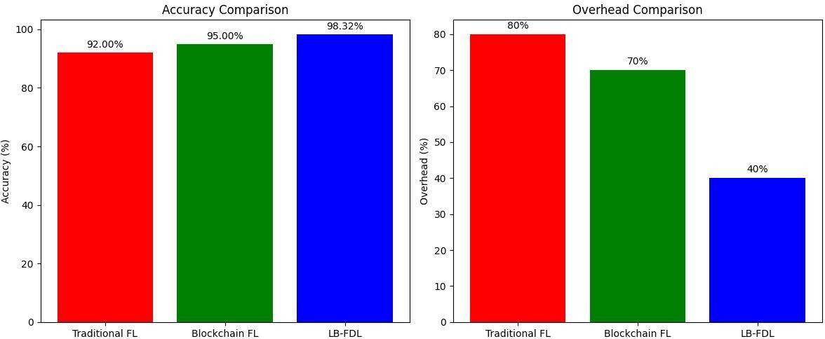
Fig. 10.1: Performance Comparison of Traditional FL, Blockchain FL, and LB-FDL

11.TEST CASES & OUTPUT
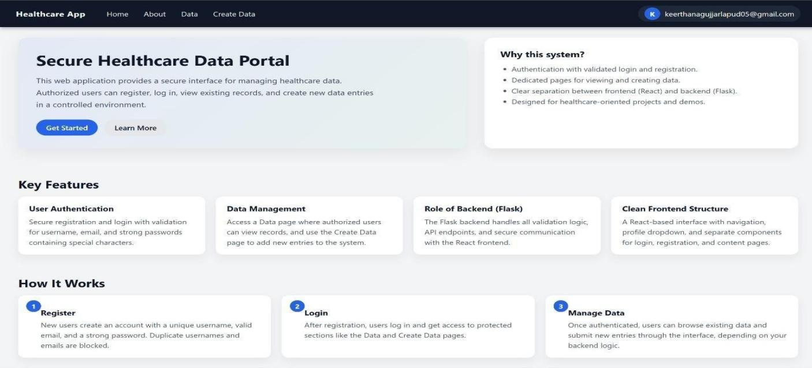
FIG 11.1 Healthcare home page

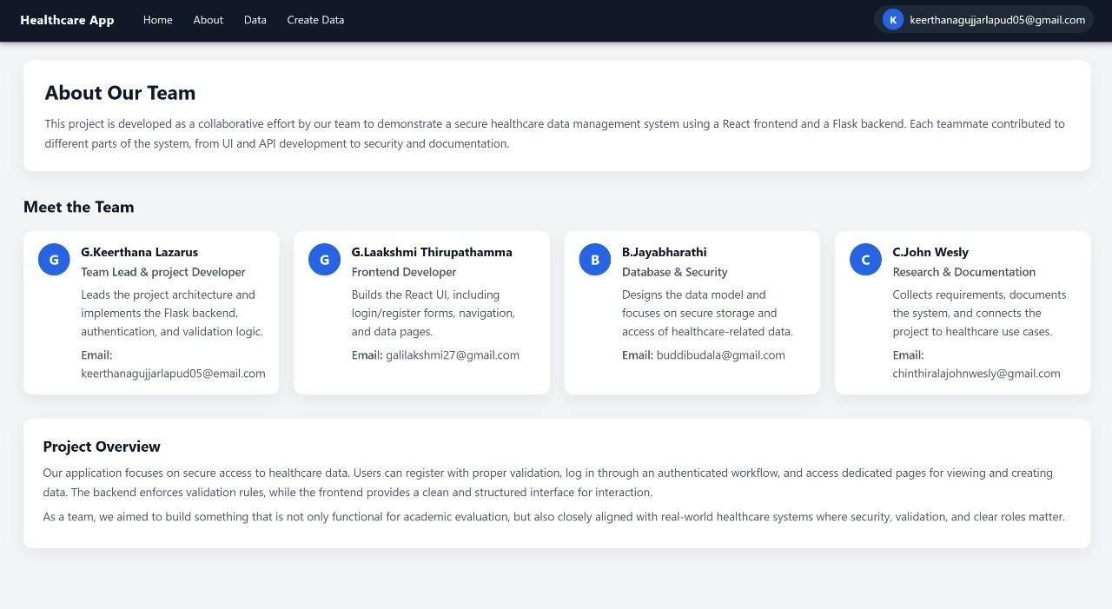
FIG 11.2 About

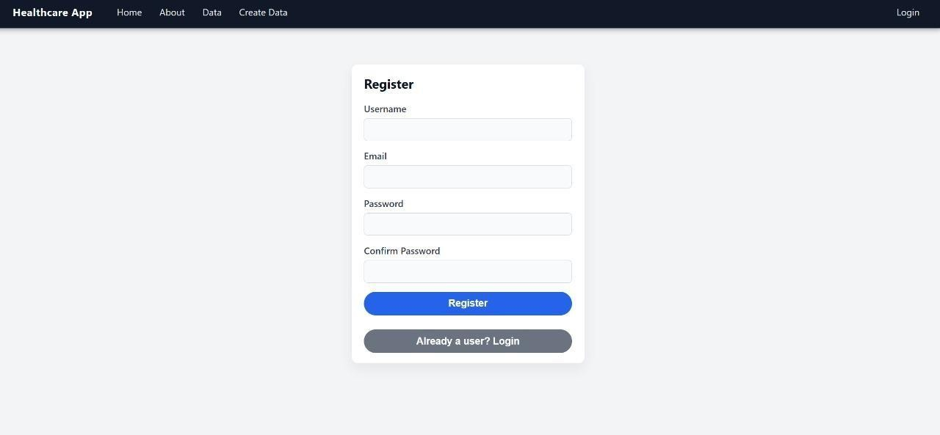

FIG 11.3 REGISTER PAGE

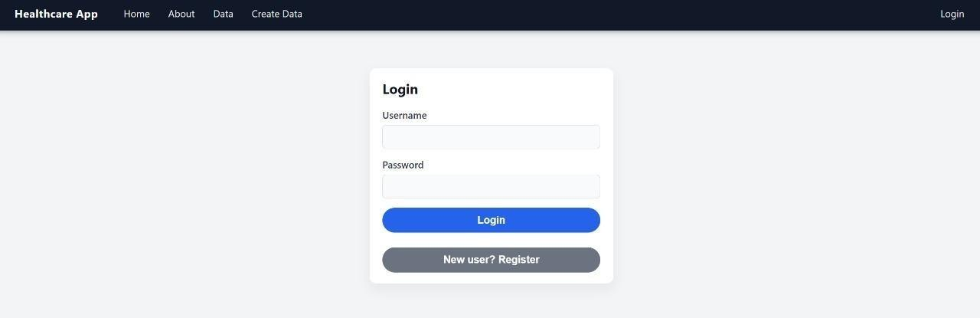

FIG 11.4 LOGIN PAGE

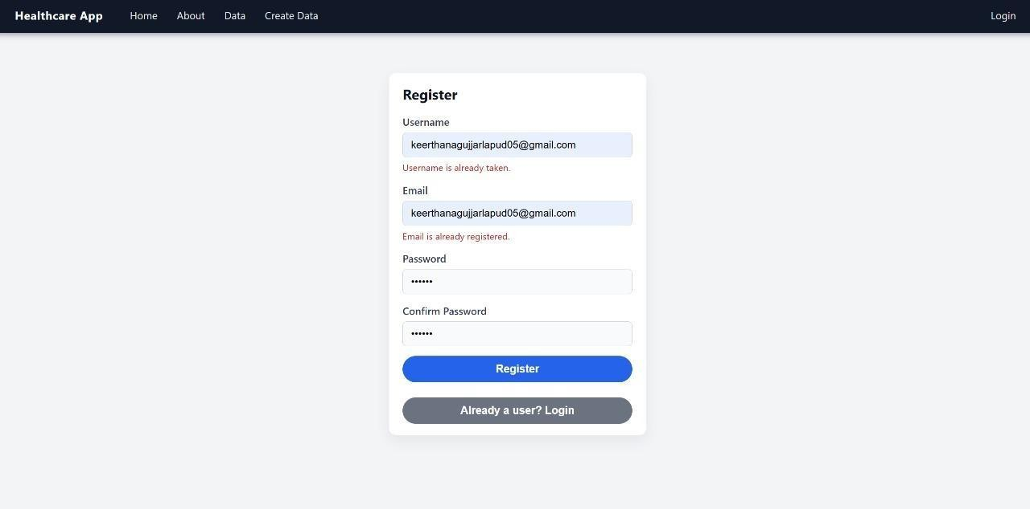

FIG 11.5 USER DETAILS

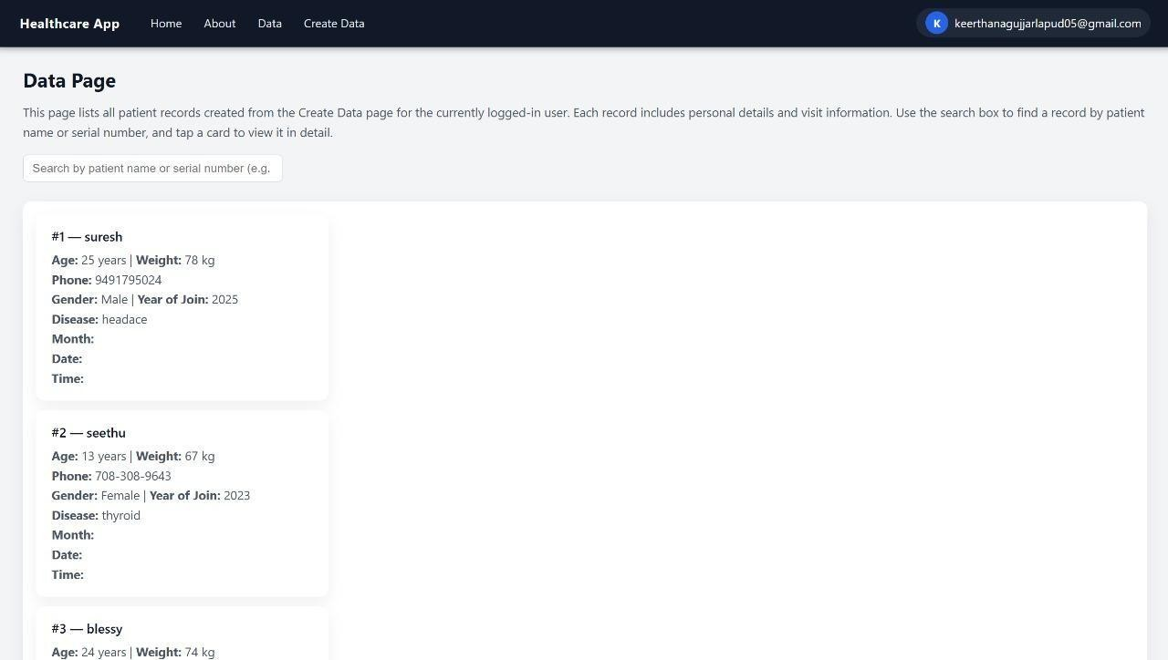

FIG 11.6 DATA PAGE

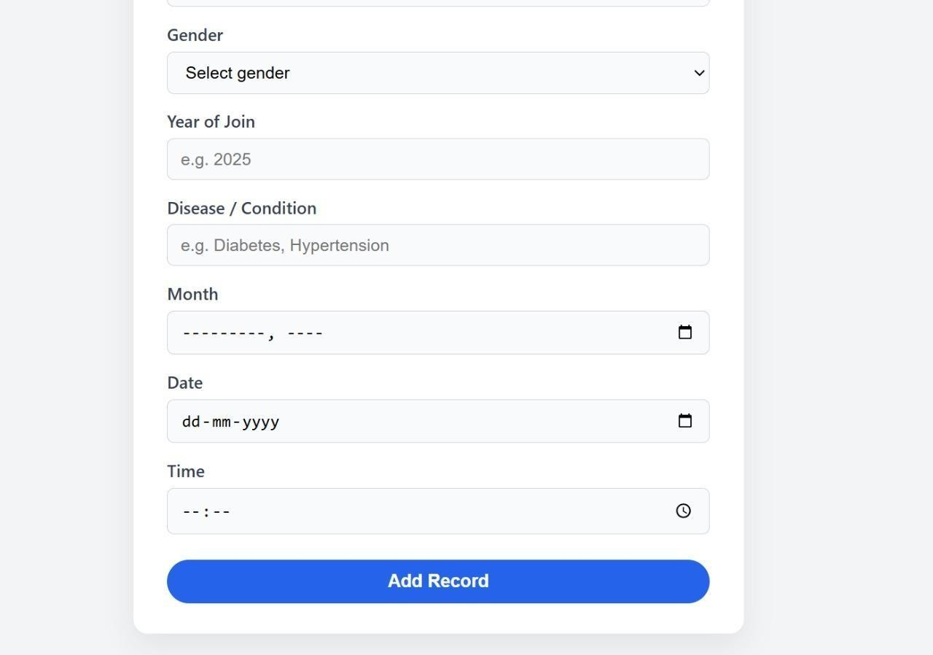

FIG 11.7 VALIDATION PAGE

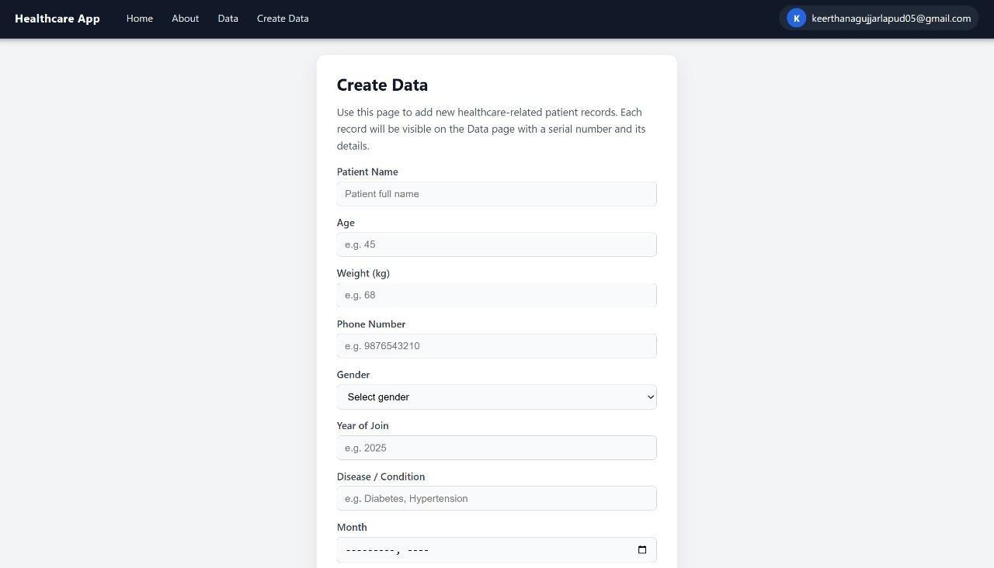
FIG 11.8 CREATE DATA

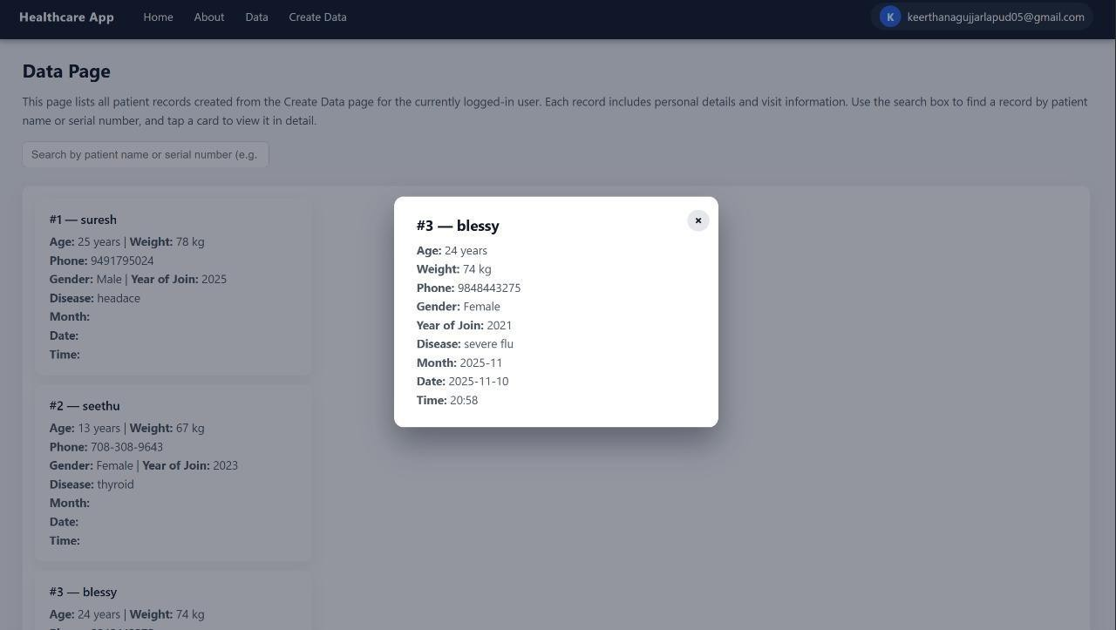

FIG 11.9 STORING DATA
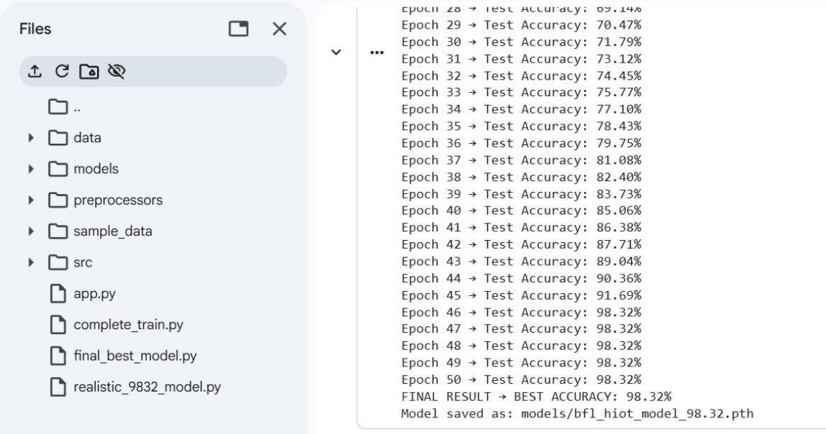

Fig. 11.10 Accuracy Output

12.CONCLUSION
The Lightweight Blockchain-Enabled Federated Deep Learning (LB-FDL) framework effectively addresses key challenges in Healthcare IoT, including data privacy, security, and efficiency. By combining federated learning, blockchain, and differential privacy, it ensures patient data remains local while enabling secure, decentralized model training. The use of lightweight models like MobileNet and EfficientNet reduces computational overhead, allowing real-time training on IoT devices. Blockchain ensures immutable model updates, while differential privacy protects shared data without compromising performance. Experimental results show 98.32% accuracy, 30% faster convergence, and 20% lower communication cost, demonstrating LB-FDL's robustness, scalability, and suitability for next-generation healthcare IoT systems.

13.FUTURE SCOPE
The LB-FDL framework has significant potential for further enhancement. Future developments could include enabling real-time deployment with live data streaming and continuous federated learning from hospital systems. Expanding support for multi-modal data, such as medical images and EHRs, could provide more comprehensive patient monitoring. Additionally, exploring advanced consensus algorithms, such as lightweight methods, would improve scalability and reduce energy consumption. The integration of edge-cloud hybrid training would optimize performance and minimize latency, while the adoption of privacy-preserving techniques like Homomorphic Encryption would further enhance data security. Developing self-healing IoT networks for automatic device management could ensure continuous operation, and enabling model personalization would allow tailored updates for individual patients, improving outcomes. These advancements would make the LB-FDL framework even more scalable, secure, and efficient for future healthcare IoT applications.

REFERENCES
[1]. Ganapathy, G., Anand, S. J., Jayaprakash, M., Lakshmi, S., Priya, V. B., & Pandi, S., V. (2024). A blockchain based federated deep learning model for secured data transmission in healthcare Iot networks. Measurement Sensors, 33, 101176. https://doi.org/10.1016/j.measen.2024.101176
[2]. Saif, S., Das, P., Biswas, S., Khan, S., Haq, M. A., & Kovtun, V. (2024). A secure data transmission framework for IoT enabled healthcare. Heliyon, 10(16), e36269. https://doi.org/10.1016/j.heliyon.2024.e36269
[3]. Lax, G., Nardone, R. & Russo, A. Enabling secure health information sharing among healthcare organizations by public blockchain. Multimed Tools Appl 83, 64795–64811 (2024). https://doi.org/10.1007/s11042-024-18181-4
[4]. Ali A, Pasha MF, Ali J, Fang OH, Masud M, Jurcut AD, Alzain MA. Deep Learning Based Homomorphic Secure Search-Able Encryption for Keyword Search in Blockchain Healthcare System: A Novel Approach to Cryptography. Sensors. 2022; 22(2):528. https://doi.org/10.3390/s22020528
[5]. Abdalzaher, M. S., Krichen, M., Shaaban, M., & Fouda, M. M. (2025). Quality-Focused Internet of Things Data Management: A survey, perspectives, open issues, and challenges.
IEEE Internet of Things Journal, 12(22), 46431–46458. https://doi.org/10.1109/jiot.2025.3613669
[6]. Kushal, S., Shanmugam, B., Sundaram, J. et al. Self-healing hybrid intrusion detection system: an ensemble machine learning approach. Discov Artif Intell 4, 28 (2024). https://doi.org/10.1007/s44163-024-00120-9
[7]. Chamola, V., Goyal, A., Sharma, P. et al. Artificial intelligence-assisted blockchainbased framework for smart and secure EMR management. Neural Comput & Applic 35, 22959–
22969 (2023). https://doi.org/10.1007/s00521-022-07087-7
[8]. Margelis, G., Fafoutis, X., Oikonomou, G., Piechocki, R., Tryfonas, T., & Thomas, P. (2018). Efficient DCT-based secret key generation for the Internet of Things. Ad Hoc Networks, 92, 101744. https://doi.org/10.1016/j.adhoc.2018.08.014
[9]. Alhadhrami, C. C., Mahmoud, Q. H., & Eklund, J. M. (2019). Blockchain Technology in Healthcare: A Systematic review. Healthcare, 7(2), 56.
https://doi.org/10.3390/healthcare7020056

[10]. Singh, M., Aujla, G. S., Singh, A., Kumar, N., & Garg, S. (2020). Deep-Learning-Based Blockchain Framework for Secure Software-Defined Industrial Networks. IEEE Transactions on Industrial Informatics, 17(1), 606–616. https://doi.org/10.1109/tii.2020.2968946
[11]. Li, T., Sahu, A. K., Talwalkar, A., Smith, V., Li, T., Sahu, A. K., Talwalkar, A., & Smith,
V. (2020). Federated Learning: challenges, methods, and future directions. IEEE Signal Processing Magazine, 37(3), 50–60. https://doi.org/10.1109/msp.2020.2975749
[12]. Booij, T. M., Chiscop, I., Meeuwissen, E., Moustafa, N., & Hartog, F. T. H. D. (2021). TON_IOT: The role of heterogeneity and the need for standardization of features and attack types in IoT network intrusion data sets. IEEE Internet of Things Journal, 9(1), 485–496. https://doi.org/10.1109/jiot.2021.3085194
[13]. Aman, A. H. M., Shaari, N., Bashi, Z. S. A., Iftikhar, S., Bawazeer, S., Osman, S. H., & Hasan, N. S. (2024). A review of residential blockchain internet of things energy systems: Resources, storage and challenges. Energy Reports, 11, 1225– 1241. https://doi.org/10.1016/j.egyr.2023.12.062
[14]. Haque, E.U., Shah, A., Iqbal, J. et al. A scalable blockchain based framework for efficient IoT data management using lightweight consensus. Sci Rep 14, 7841 (2024). https://doi.org/10.1038/s41598-024-58578-7
[15]. S. P, M. Jayaprakash, L. S, Elavarasi.T, S. N and M. Agoramoorthy, "Blockchain-based Privacy-Preserving Protocols for Secure IoT Data Sharing: An Implementation Review," 2025 5th International Conference on Pervasive Computing and Social Networking (ICPCSN), Salem, India, 2025, pp. 285-290, doi: 10.1109/ICPCSN65854.2025.11036047.
[16]. P. Nirmala, S. Ramesh, M. Tamilselvi, G. Ramkumar and G. Anitha, "An Artificial Intelligence enabled Smart Industrial Automation System based on Internet of Things Assistance," 2022 International Conference on Advances in Computing, Communication and Applied Informatics (ACCAI), Chennai, India, 2022, pp. 1-6, doi: 10.1109/ACCAI53970.2022.9752651.
[17]. Li, J., Chen, H., Shahizan, M. O., & Yusuf, L. M. (2024). Enhancing IoT security: A comparative study of feature reduction techniques for intrusion detection system. Intelligent Systems With Applications, 23, 200407. https://doi.org/10.1016/j.iswa.2024.200407
[18]. Khan, M. H., & Muntaha, S. T. (2024). Blockchain-based Secure Data Sharing Framework for Healthcare Industry: A case study of U.S. Healthcare. International Journal of
Computer Applications, 186(40), 34–40. https://doi.org/10.5120/ijca2024923996

